Exercise 7

Experimenting with App Layouts and Color Schemes: A Design, Feedback, and Refinement Approach

Name : Praveen R
Register Number:230701244

AIM
The aim is to trial different app layouts and color schemes and evaluate user feedback on aesthetics and usability using GIMP.

Introduction

In this exercise, I explored the process of designing an app layout by experimenting with different color schemes and structures.
The main objective was not just to create visually appealing screens but also to focus on aesthetics, usability, and user experience.

After designing multiple versions, I collected (imaginary) user feedback to understand preferences and pain points.
Based on the feedback, I refined the design, selected the most effective color and layout combination, and finalized professional, user-friendly app screens.

This documentation explains each step I followed — from the initial design to feedback evaluation and final improvements — as per the given exercise guidelines.

- Starting the Design
I began by creating a simple app layout with three main screens:
- Home Page
- Signup Page
- Login Page
Each screen has basic elements like:
Titles and text
Input boxes (for email, password, etc.)
Buttons to submit or go to the next page
I arranged everything neatly with proper spacing and alignment to keep it clear and easy to use.

2. Trying Out Color Combinations
Home Page
- Version 1:
  - Background: Dark Maroon
  - Button: Blue
- Version 2:
  - Background: Bright Pink
  - Button: Blue
Signup Page
- Version 1:
  - Background: Dark Maroon
  - Input fields: White
  - Button: Blue
- Version 2:
  - Background: Bright Pink
  - Input fields: White
  - Button: Blue
Login Page
- Version 1:
  - Background: Dark Maroon
  - Input fields: White
  - Button: Blue
- Version 2:
  - Background: Bright Pink
  - Input fields: White
  - Button: Blue

3. Getting User Feedback (Imaginary Session)
Here’s what users said:
- Maroon Background (All Pages)
  - Looks too dark and serious
  - Buttons are okay, but the screen feels dull
- Pink Background (All Pages)
  - Too bright and hard on the eyes
  - Distracts from the input fields

4. Making Improvements Based on Feedback
After reviewing the feedback, I made changes to improve the design:
- New Background Color:
  - I chose a soft light blue color (#B0E0E6) for all pages. It looks calm, clean, and more welcoming.
- Input Fields:
  - Kept them white for clear visibility
- Buttons:
  - Changed to a softer blue (#6A8CCD) for a professional and smooth look
- Text:
  - Made titles like “Welcome Back” bolder and more friendly
  - Aligned all text and input boxes for better clarity

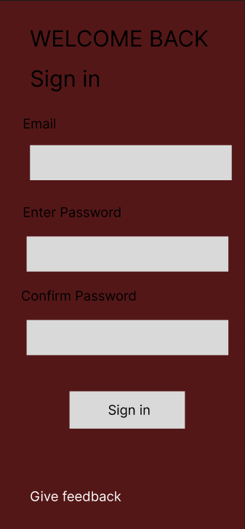

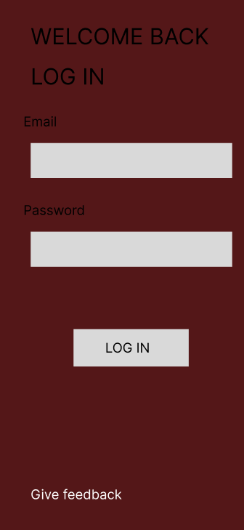

Latest Design Update
What I Changed
I made a new version of the Sign Up and Login pages.
This time, I used a gray background instead of maroon, pink, or light blue.

Why I Tried Gray
- Maroon looked too dark
- Pink was too bright
- Light blue was nice, but I wanted to try something more neutral
Gray is simple and clean. It helps users focus on the input boxes and buttons.

What’s in the New Version?
- Gray background
- White input boxes for email and password
- Light gray buttons
- Text is easy to read and layout is clear

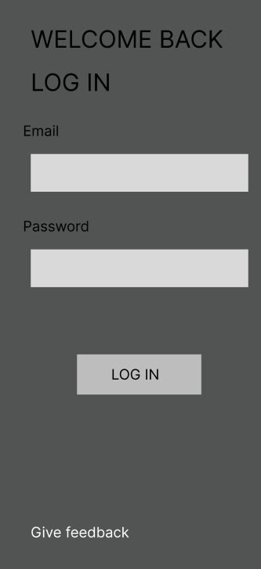

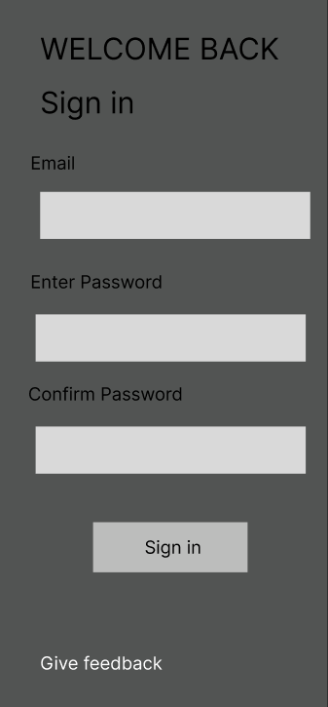

Login Page (Initial Versions)

Version 1:

• Background: Dark Maroon

• White Input Fields

• Blue Button

Version 2:

• Background: Bright Pink

• White Input Fields

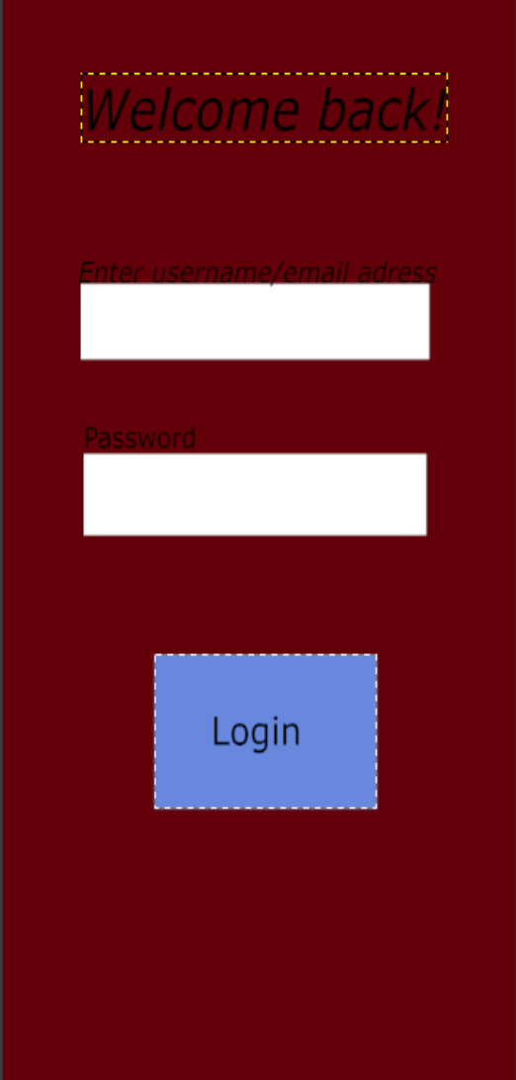
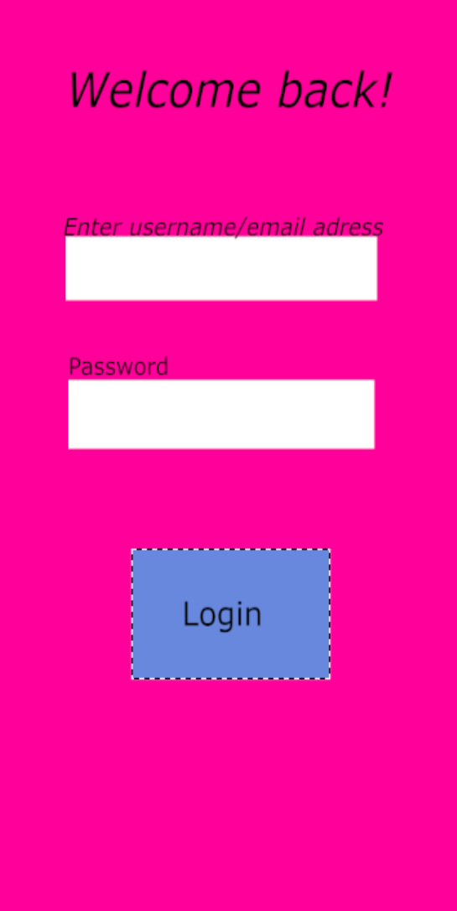
• Blue Button

user FeedbAck coLLectIon

I conducted an imaginary feedback collection session to get perceptions about the designs. Here are the feedback points received:

• Home Page (Maroon Background):

o Looked too dark and serious.

o Buttons were good but not very lively.

• Home Page (Pink Background):

o Very vibrant but a little harsh on the eyes for daily use.

• Signup Page (Pink Background):

o Very bright and overwhelming.

o Input fields were clear, but background distracted users.

• Signup Page (Maroon Background):

o Slightly better than pink.

o Still, background color needed to be softer for professional use.

• Login Page (Maroon Background):

o Looked too dark and heavy.

o Buttons were visible but the screen felt dull and serious.

• Login Page (Pink Background):

o Bright but too distracting.

o Input fields were clear but background took away user focus.

reActIon to FeedbAck And reFIneMent

After evaluating feedback, I made the following refinements:

• For Home Page:

o Changed background to Light Blue (#B0E0E6) for a soft, welcoming look.

o Maintained the Blue Buttons.

• For Signup Page:

o Changed background to Light Blue (#B0E0E6) (same as Home Page) for consistency.

o Input fields kept white for clarity.

o Button colored Blue (#6A8CCD) for a calm, professional feel.

o Aligned text elements neatly.

• For Login Page:

o Updated background to Light Blue (#B0E0E6) for a softer, welcoming login experience.

o Retained White input fields for clarity.

o Used the same Blue (#6A8CCD) for the Login button for consistency.

o Made welcome text ("Welcome back!") bold and more friendly.

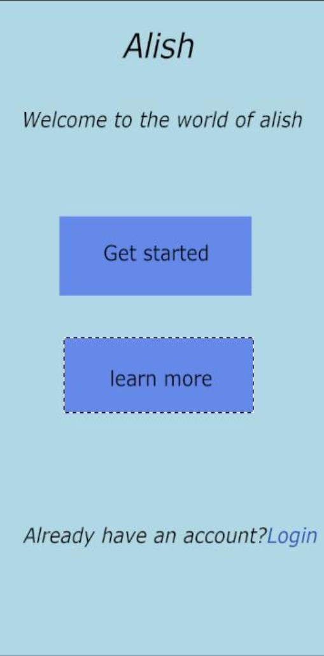
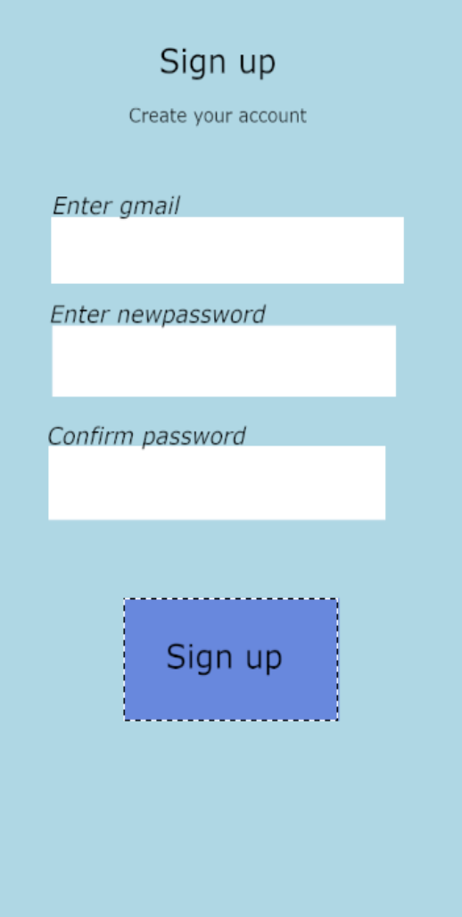
All UI elements were aligned properly with better padding, ensuring that the design not only looked good but also supported excellent usability.
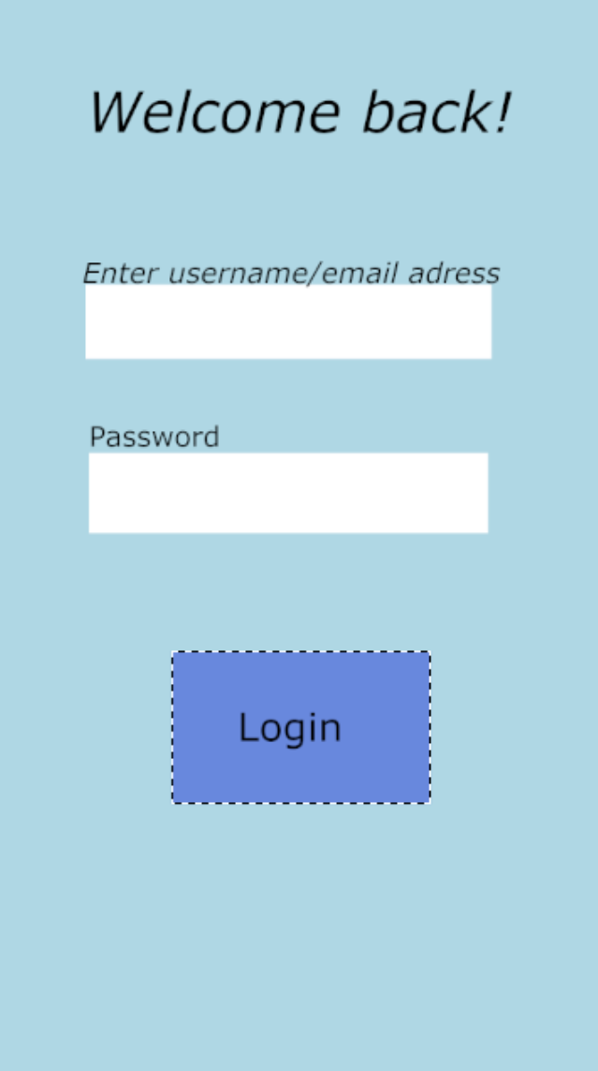

FInAL coLor codes used

UI Element Color Hex Code

Home Page Background Light Blue #B0E0E6

Signup Page Background Light Blue #B0E0E6

Login Page Background Light Blue #B0E0E6

Button Blue #6A8CCD

UI Element

Input Fields

Text
Color Hex Code

White #FFFFFF

Black #000000

FInAL resuLt

After completing the above steps:

• I achieved a professional, user-friendly, and visually pleasing app layout for the Home, Signup, and Login Pages.

• I made design decisions based on user feedback, improving the overall user experience.

• The final versions satisfy both aesthetic beauty and usability as per the objective of the assignment.

concLusIon

Through this exercise, I learned the importance of:

• Exploring different layouts and color schemes,

• Collecting and reacting to feedback, and

• Refining the design to suit both aesthetic and functional needs.

The final app layouts achieved a balance of professional appearance, ease of use, and user comfort, perfectly meeting the aims of the exercise.

